ASSIGNMENT 6 CSE 220
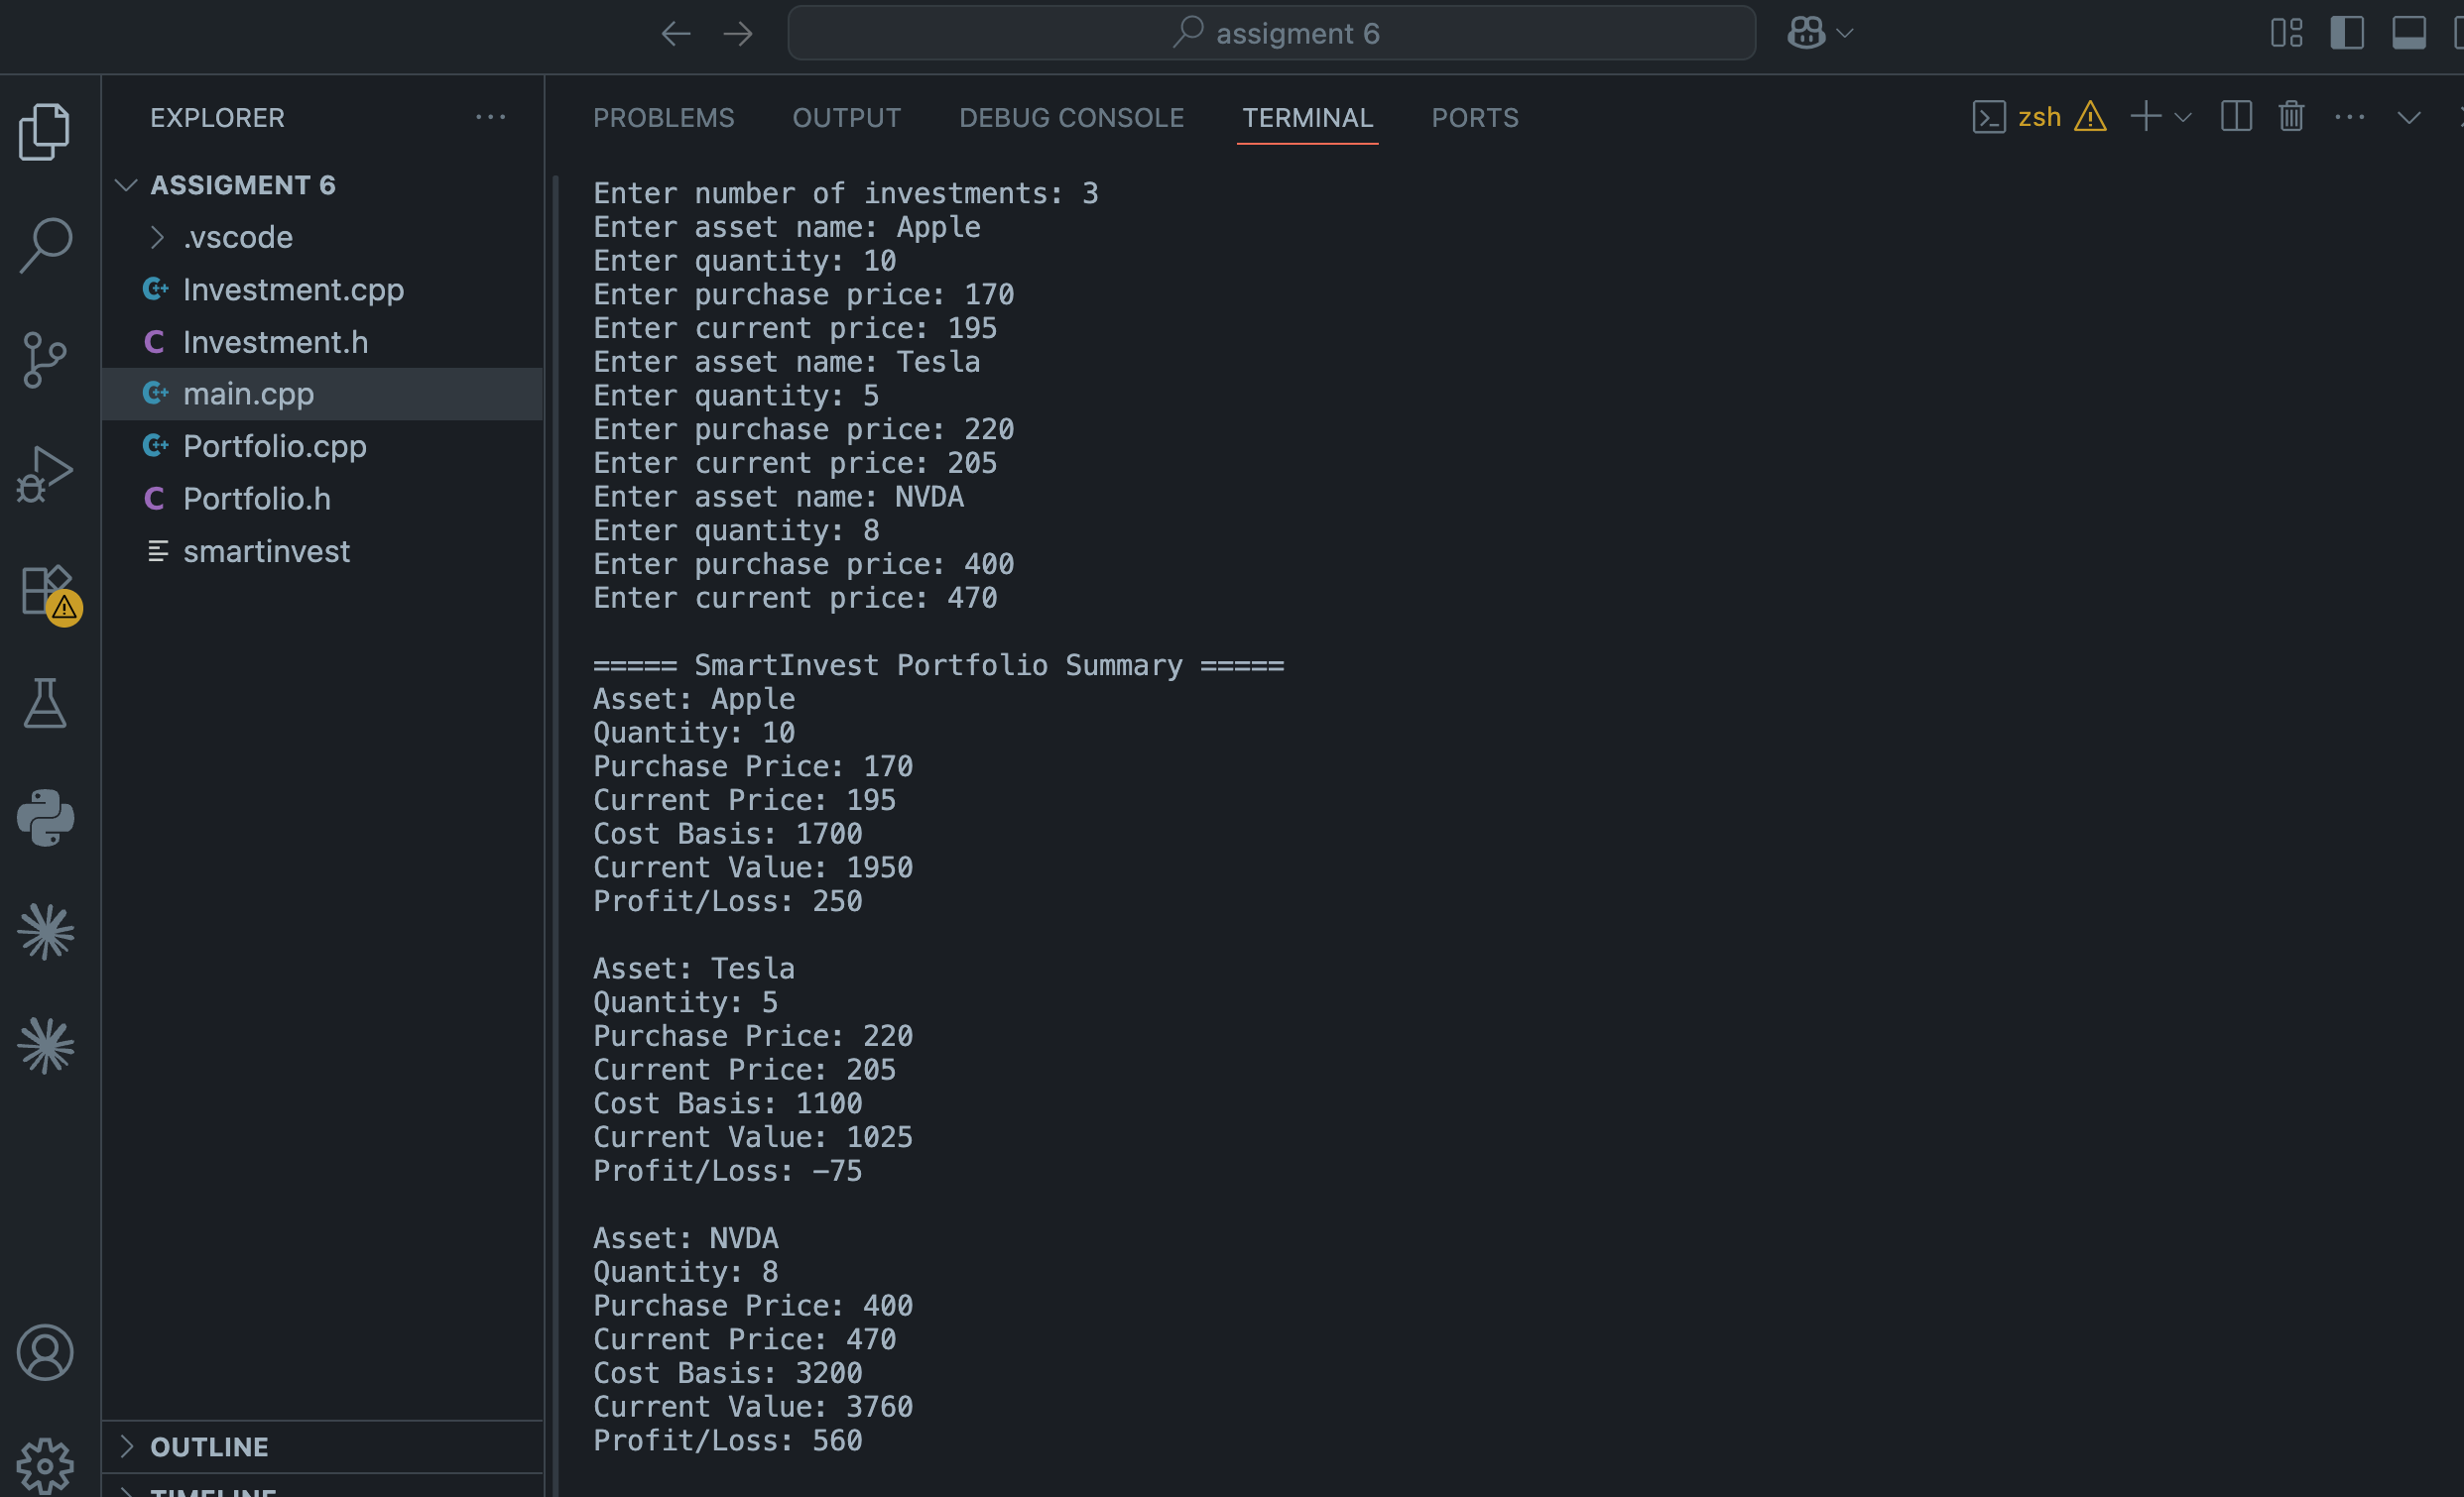
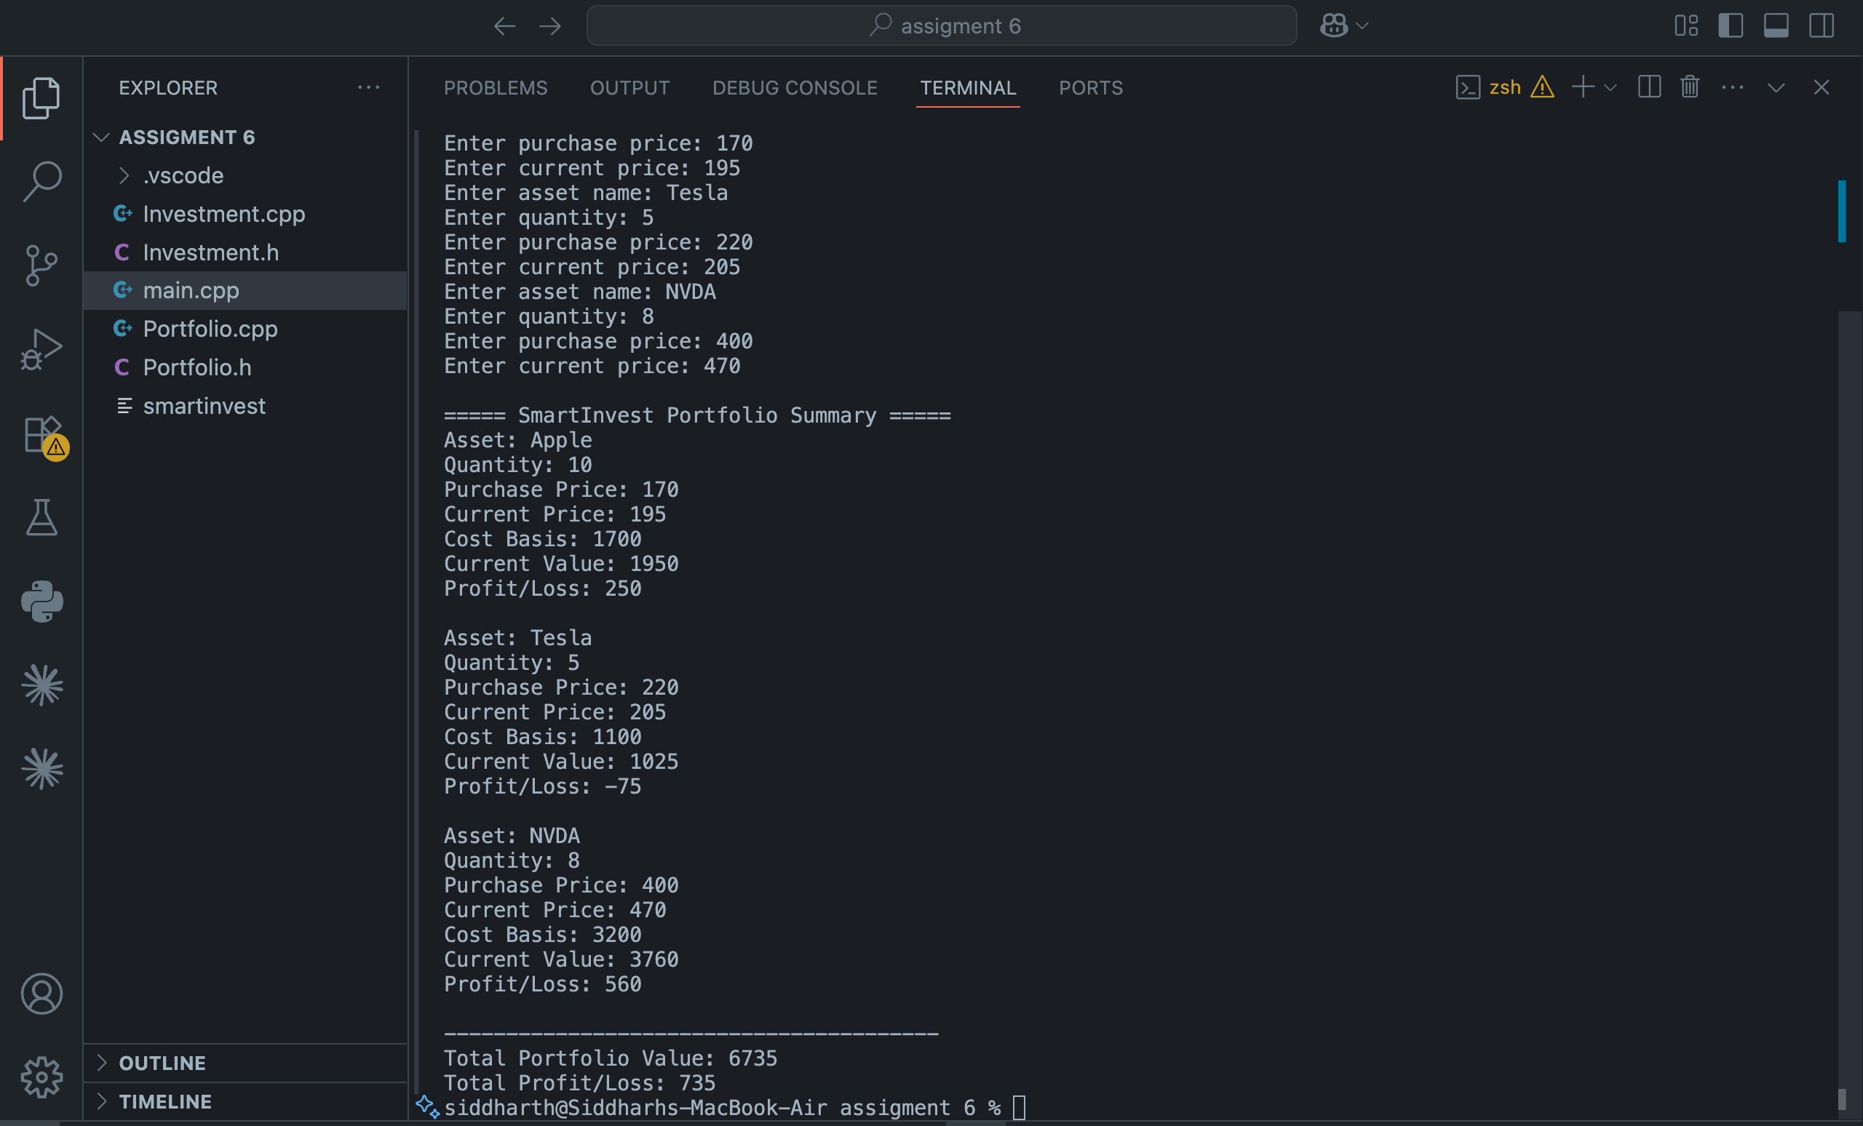

Explanation: Two classes split across header and cpp files. Investment holds the asset name, quantity, purchase price, and current price, and has methods for cost basis, current value, and profit/loss. Portfolio stores a vector of investments and sums them up for the totals. Main just asks the user how many investments they want to enter, loops through collecting the info, and prints the summary at the end. All members are private and there are no globals, so encapsulation is handled. Output matches the example in the spec.

